**DBS 301 - Assignment 3 – Section D, WINTER 2018**

**Prof. Nebojsa Conkic**

**TABLES:**

1. **CUSTOMERS**

CREATE TABLE CUSTOMERS(

CUST_NO NUMBER (25) NOT NULL,

LNAME VARCHAR(25) NOT NULL,

DOB DATE,

ADDRESS VARCHAR(25) ,

CITY VARCHAR (25) NOT NULL,

PROV VARCHAR (25) NOT NULL,

POST_CODE VARCHAR (25) NOT NULL,

EMAIL VARCHAR(35),

CONSTRAINT CUST_NO_PK PRIMARY KEY (CUST_NO),

CONSTRAINT EMAIL_UK UNIQUE (EMAIL) );

1. **Orders:**

create table orders(

orderId number(25) not null,

orderDate varchar(25) not null,

orderTotal number(25) not null,

cust_id number(25) not null,

constraint orderId_pk primary key (orderId),

constraint cust_id_fk foreign key (cust_id) REFERENCES customers (cust_no));

1. **PAYMENT**

CREATE TABLE PAYMENT(

ORDER_ID NUMBER(25) NOT NULL,

CARD_NO NUMBER (25) NOT NULL,

CARD_HOLDER VARCHAR(25) NOT NULL,

EXP_DATE DATE NOT NULL,

CARD_TYPE VARCHAR (25) NOT NULL,

CONSTRAINT CARD_NO_PK PRIMARY KEY (CARD_NO),

CONSTRAINT ORDER_ID_FK FOREIGN KEY (ORDER_ID) REFERENCES ORDERS (ORDERID),

CONSTRAINT C_T_CK CHECK (CARD_TYPE IN ('A','D','M','V')));

1. **ORDERLINE**

CREATE TABLE ORDERLINE(

ORDER_ID NUMBER(25) NOT NULL,

LINE# NUMBER (25) NOT NULL,

QTY NUMBER(25) NOT NULL,

ACT_PRICE DECIMAL(4,2) NOT NULL,

REC_ID NUMBER (25) NOT NULL,

CONSTRAINT LINE#_PK PRIMARY KEY (LINE#),

CONSTRAINT O_ID_FK FOREIGN KEY (ORDER_ID) REFERENCES ORDERS (ORDERID),

CONSTRAINT R_ID_FK FOREIGN KEY (REC_ID) REFERENCES RECORDING (REC_ID),

CONSTRAINT QTY_CK CHECK (QTY >= 0 ),

CONSTRAINT ACT_PRICE_CK CHECK (ACT_PRICE >= 0 ));

1. **REGION**

CREATE TABLE REGION (

REGION_ID NUMBER(25) NOT NULL,

REGION_NAME VARCHAR (25) NOT NULL,

CONSTRAINT REGION_ID_PK PRIMARY KEY (REGION_ID),

CONSTRAINT R_N_UK UNIQUE (REGION_NAME));

1. **LABEL**

CREATE TABLE LABEL (

LABEL_ID NUMBER(25) NOT NULL,

LABEL_NAME VARCHAR (25) NOT NULL,

LABEL_URL VARCHAR(512) NOT NULL,

CONSTRAINT LABEL_ID_PK PRIMARY KEY (LABEL_ID),

CONSTRAINT LABEL_NAME_UK UNIQUE (LABEL_NAME),

CONSTRAINT URL_UK UNIQUE (LABEL_URL));

1. **CATEGORY**

CREATE TABLE CATEGORY (

CAT_ID NUMBER(25) NOT NULL,

CAT_DESC VARCHAR (25) NOT NULL,

CONSTRAINT CAT_ID_PK PRIMARY KEY (CAT_ID),

CONSTRAINT CAT_DESC_UK UNIQUE (CAT_DESC));

1. **SALES REPRESENTATIVE**

CREATE TABLE SALES_REP(

LABEL_ID NUMBER(25) NOT NULL,

REP_ID NUMBER(25) NOT NULL,

LNAME VARCHAR(25) NOT NULL,

FNAME VARCHAR (25) NOT NULL,

PHONE_NO NUMBER(25) NOT NULL,

EMAIL VARCHAR(25),

REGION_ID NUMBER(25) NOT NULL,

CONSTRAINT REP_ID_PK PRIMARY KEY (REP_ID),

CONSTRAINT L_ID_FK FOREIGN KEY (LABEL_ID) REFERENCES LABEL (LABEL_ID),

CONSTRAINT RG_ID_FK FOREIGN KEY (REGION_ID) REFERENCES REGION (REGION_ID),

CONSTRAINT PH_UK UNIQUE (PHONE_NO),

CONSTRAINT EM_UK UNIQUE (EMAIL));

1. **RECORDING**

CREATE TABLE RECORDING (

REC_ID NUMBER(25) NOT NULL,

TITLE VARCHAR (25) NOT NULL,

ARTIST VARCHAR (25) NOT NULL,

SELL_PRICE DECIMAL(4,2) NOT NULL,

QTY_IN_STOCK NUMBER(25),

CAT_ID NUMBER(25) NOT NULL,

LABEL_ID NUMBER(25) NOT NULL,

CONSTRAINT REC_ID_PK PRIMARY KEY (REC_ID),

CONSTRAINT LABEL_ID_FK FOREIGN KEY (LABEL_ID) REFERENCES LABEL (LABEL_ID),

CONSTRAINT CAT_ID_FK FOREIGN KEY (CAT_ID) REFERENCES CATEGORY (CAT_ID),

CONSTRAINT QIS_CK CHECK (QTY_IN_STOCK > = 0),

CONSTRAINT SP_CK CHECK (SELL_PRICE > = 0));

1. **RECORDING HISTORY**

CREATE TABLE REC_HIST(

REC_ID NUMBER(25) NOT NULL,

PRICE_ID NUMBER(25) NOT NULL,

PRICE DECIMAL(4,2) NOT NULL,

START_DATE DATE NOT NULL,

CONSTRAINT P_ID_PK PRIMARY KEY (PRICE_ID),

CONSTRAINT RECORD_ID_FK FOREIGN KEY (REC_ID) REFERENCES RECORDING (REC_ID));

**Inserts:**

1. **Customers**

INSERT INTO CUSTOMERS VALUES

('126330166', 'Ahmed', '1999-02-25', '1435 Woodbine Ave', 'Toronto', 'ON', 'M4C4G8', 'msyahmed@myseneca.ca' );

INSERT INTO CUSTOMERS VALUES

('123456893', 'Yusuf', '1996-01-25', '1435 Woodbine Ave', 'Toronto', 'ON', 'M4C6G8', '123@myseneca.ca' );

INSERT INTO CUSTOMERS VALUES

('12345893', 'Ali', '1991-05-22', '14 Lumsden Ave', 'Scarborough', 'ON', 'M2C6G8', '1223@myseneca.ca' );

1. **Orders**

INSERT INTO ORDERS VALUES

('123', '2009-05-22', '14', '126330166' );

INSERT INTO ORDERS VALUES

('211', '2009-02-22', '11', '123456893' );

INSERT INTO ORDERS VALUES

('11', '2001-04-12', '121', '12345893' );

1. **Label**

INSERT INTO LABEL VALUES

('1', 'TSERIES', 'www.tseries.com');

INSERT INTO LABEL VALUES

('2', 'SONY', 'www.sonymusic.ca');

INSERT INTO LABEL VALUES

('3', 'ZEE', 'www.zee.com');

1. **Payment**

INSERT INTO PAYMENT VALUES

('123', '123456789', 'Zia', '2019-02-02', 'V');

INSERT INTO PAYMENT VALUES

('211', '123416789', 'Ali', '2029-03-02', 'M');

INSERT INTO PAYMENT VALUES

('11', '123156789’, 'Yusuf', '2025-06-07', 'A');

1. **Region**

INSERT INTO REGION VALUES

('1', 'TORONTO' );

INSERT INTO REGION VALUES

('2', 'MEXICO' );

INSERT INTO REGION VALUES

('3', 'WATERLOO' );

1. **Category**

INSERT INTO CATEGORY VALUES

('1', 'ROCK' );

INSERT INTO CATEGORY VALUES

('2', 'POP' );

INSERT INTO CATEGORY VALUES

('3', 'Alt Rock' );

1. **RECORDING**

INSERT INTO RECORDING VALUES

('1', 'Jal', 'Atif Aslam', '10', '5', '3', '1' );

INSERT INTO RECORDING VALUES

('2', 'RiseUp', 'Yusuf', '8', '8', '2', '2' );

INSERT INTO RECORDING VALUES

('3', 'Rock On', 'Shery', '15', '3', '1', '3' );

1. **Sales Representative**

INSERT INTO SALES_REP VALUES

('1', '1', 'Aslam', 'Atif', '923004505781', 'atif@gmail.com', '1' );

INSERT INTO SALES_REP VALUES

('2', '2', 'Azmat', 'Ali', '923024505781', 'ali@gmail.com', '2' );

INSERT INTO SALES_REP VALUES

('3', '3', 'Muhammad', 'Ahmed', '2049144074', 'shery@gmail.com', '3' );

1. **Recording History**

INSERT INTO REC_HIST VALUES

('1', '1', '10', '2004-04-26' );

INSERT INTO REC_HIST VALUES

('2', '2', '8', '2003-03-12' );

INSERT INTO REC_HIST VALUES

('3', '3', '15', '2019-05-21' );

1. **Order Line**

INSERT INTO ORDERLINE VALUES

('123', '1', '10', '10', '1' );

INSERT INTO ORDERLINE VALUES

('211', '2', '12', '3', '2' );

INSERT INTO ORDERLINE VALUES

('11', '3', '60', '55', '3' );

**VIEW**

CREATE VIEW Cust_Cat_AR AS(

SELECT C.LNAME, C.CITY, DOB, R.ARTIST, R.TITLE

FROM CUSTOMERS C, RECORDING R, ORDERS O, ORDERLINE L, CATEGORY B

WHERE C.CUST_NO = O.CUST_ID

AND O.ORDERID = L.ORDER_ID

AND L.REC_ID = R.REC_ID

AND R.CAT_ID = B.CAT_ID

AND B.CAT_DESC = 'Alt Rock'

);

**SELECT * FROM Cust_Cat_AR;**

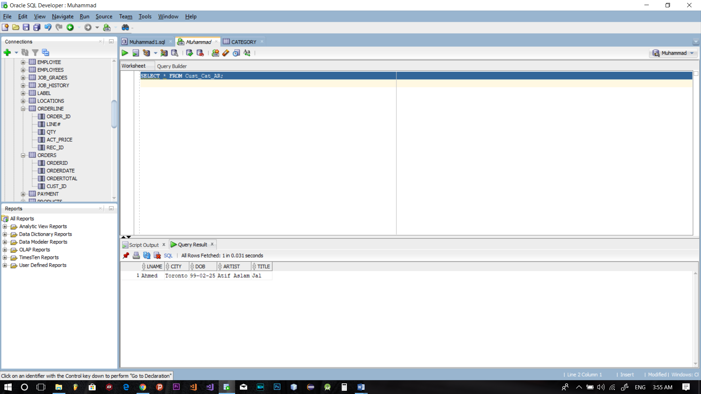

**Inserts**

**Orders**

INSERT INTO ORDERS VALUES

('123', '2009-05-22', '14', '126330166' );

INSERT INTO ORDERS VALUES

('211', '2009-02-22', '11', '123456893' );

INSERT INTO ORDERS VALUES

('11', '2001-04-12', '121', '12345893' );

**Payment**

INSERT INTO PAYMENT VALUES

('123', '123456789', 'Zia', '2019-02-02', 'V');

INSERT INTO PAYMENT VALUES

('211', '123416789', 'Ali', '2029-03-02', 'M');

INSERT INTO PAYMENT VALUES

('11', '123156789’, 'Yusuf', '2025-06-07', 'A');

**RECORDING**

INSERT INTO RECORDING VALUES

('1', 'Jal', 'Atif Aslam', '10', '5', '3', '1' );

INSERT INTO RECORDING VALUES

('2', 'RiseUp', 'Yusuf', '8', '8', '2', '2' );

INSERT INTO RECORDING VALUES

('3', 'Rock On', 'Shery', '15', '3', '1', '3' );

**Sales Representative**

INSERT INTO SALES_REP VALUES

('1', '1', 'Aslam', 'Atif', '923004505781', 'atif@gmail.com', '1' );

INSERT INTO SALES_REP VALUES

('2', '2', 'Azmat', 'Ali', '923024505781', 'ali@gmail.com', '2' );

INSERT INTO SALES_REP VALUES

('3', '3', 'Muhammad', 'Ahmed', '2049144074', 'shery@gmail.com', '3' );

**Recording History**

INSERT INTO REC_HIST VALUES

('1', '1', '10', '2004-04-26' );

INSERT INTO REC_HIST VALUES

('2', '2', '8', '2003-03-12' );

INSERT INTO REC_HIST VALUES

('3', '3', '15', '2019-05-21' );

**Order Line**

INSERT INTO ORDERLINE VALUES

('123', '1', '10', '10', '1' );

INSERT INTO ORDERLINE VALUES

('211', '2', '12', '3', '2' );

INSERT INTO ORDERLINE VALUES

('11', '3', '60', '55', '3' );